|  |  |  |  |  |  |  |  |  |  |
| --- | --- | --- | --- | --- | --- | --- | --- | --- | --- |
|  | | | | | | | | | |
|  | Report on Lab-04  DATABASE MANAGEMENT SYSTEMS LAB | | | | | |  | |
|  |  | | | | | | |  | | |
| Submitted by  Adid-Al-Mahamud Shazid  Student Id: 210042172  Department: CSE  Programme: SWE  Course Title: CSE 4308  Submitted to  Zannatun Naim Sristy  Lecturer, Department of CSE  September 07, 2023 | |  | | | | |
|  |
|  | | |  |
|  | |  | | | |  | | | |

**Introduction**

In this lab class, we were given tasks based on advanced data manipulation techniques to solve using SQL command line to understand the basics of data definition and data manipulation.

**Task**

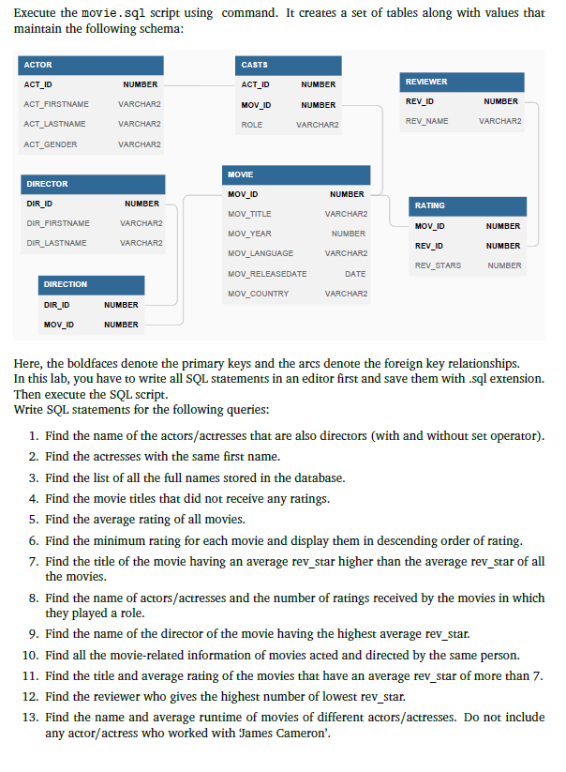

**Solution**

1. --TASK 1
2. SELECT ACT_FIRSTNAME|| ' ' || ACT_LASTNAME AS NAME FROM ACTOR, DIRECTOR WHERE ACT_FIRSTNAME=DIR_FIRSTNAME AND ACT_LASTNAME=DIR_LASTNAME;
3. SELECT ACT_FIRSTNAME || ' ' || ACT_LASTNAME AS NAME FROM ACTOR INTERSECT SELECT DIR_FIRSTNAME || ' ' || DIR_LASTNAME AS NAME FROM DIRECTOR;
4. --TASK 2
5. SELECT ACT_FIRSTNAME FROM ACTOR WHERE ACT_GENDER = 'F' GROUP BY ACT_FIRSTNAME HAVING COUNT(*)>1;
6. --TASK 3
7. SELECT ACT_LASTNAME|| ' ' || ACT_LASTNAME AS NAME FROM ACTOR UNION SELECT DIR_FIRSTNAME|| ' ' || DIR_LASTNAME FROM DIRECTOR;
8. --TASK 4
9. SELECT MOV_TITLE FROM MOVIE WHERE MOV_ID NOT IN (SELECT MOV_ID FROM RATING);
10. --TASK 5
11. SELECT AVG(REV_STARS) FROM RATING;
12. --TASK 6
13. SELECT MOV_TITLE, MIN(REV_STARS) AS MIN_RATE FROM RATING NATURAL JOIN MOVIE GROUP BY MOV_TITLE ORDER BY MIN_RATE DESC;
14. --TASK 7
15. SELECT MOV_TITLE FROM MOVIE WHERE MOV_ID IN(SELECT MOV_ID FROM RATING GROUP BY MOV_ID HAVING AVG(REV_STARS) > (SELECT AVG(REV_STARS) FROM RATING));
16. --TASK 8
17. SELECT ACT_FIRSTNAME, ACT_LASTNAME, COUNT(*) AS number_of_ratings FROM ACTOR, CASTS, RATING WHERE ACTOR.ACT_ID = CASTS.ACT_ID AND CASTS.MOV_ID = RATING.MOV_ID
18. GROUP BY ACT_FIRSTNAME , ACT_LASTNAME ORDER BY number_of_ratings DESC;
19. --TASK 9
20. SELECT DIR_FIRSTNAME,DIR_LASTNAME FROM DIRECTOR WHERE DIR_ID IN (SELECT DIR_ID FROM MOVIE JOIN RATING USING (MOV_ID) GROUP BY DIR_ID
21. HAVING AVG(REV_STARS) = (SELECT MAX(AVG(REV_STARS)) FROM MOVIE JOIN RATING USING (MOV_ID) GROUP BY DIR_ID));
22. --TASK 10
23. SELECT *
24. FROM MOVIE
25. WHERE MOV_ID
26. IN
27. (
28. SELECT DN.MOV_ID
29. FROM DIRECTION DN
30. WHERE DN.DIR_ID
31. IN
32. (
33. SELECT D.DIR_ID
34. FROM DIRECTOR D
35. WHERE D.DIR_FIRSTNAME || ' ' || D.DIR_LASTNAME
36. IN
37. (
38. SELECT D1.DIR_FIRSTNAME || ' ' || D1.DIR_LASTNAME AS DIR_NAME1
39. FROM DIRECTOR D1
40. INTERSECT
41. SELECT A.ACT_FIRSTNAME || ' ' || A.ACT_LASTNAME AS ACT_NAME
42. FROM ACTOR A
43. )
44. )
45. );
46. --TASK 11
47. SELECT M.MOV_TITLE,
48. (
49. SELECT avg(R.REV_STARS)
50. FROM RATING R
51. WHERE R.MOV_ID = M.MOV_ID
52. AND R.REV_STARS IS NOT NULL
53. ) AS AVG_RATE
54. FROM MOVIE M
55. WHERE M.MOV_ID
56. IN
57. (
58. SELECT R1.MOV_ID
59. FROM RATING R1
60. WHERE R1.REV_STARS IS NOT NULL
61. GROUP BY R1.MOV_ID
62. HAVING avg(R1.REV_STARS) > 7
63. )
64. ORDER BY AVG_RATE DESC;
65. --TASK 12
66. SELECT R.REV_NAME
67. FROM REVIEWER R
68. WHERE R.REV_ID
69. IN
70. (
71. SELECT RT.REV_ID
72. FROM RATING RT
73. WHERE RT.REV_STARS =
74. (
75. SELECT min(REV_STARS)
76. FROM RATING
77. )
78. );
79. --TASK 13
80. SELECT A.ACT_FIRSTNAME || ' ' ||A.ACT_LASTNAME AS ACT_NAME,
81. (
82. SELECT avg(M.MOV_TIME)
83. FROM MOVIE M
84. WHERE M.MOV_ID
85. IN
86. (
87. SELECT C.MOV_ID
88. FROM CASTS C
89. WHERE C.ACT_ID = A.ACT_ID
90. )
91. AND M.MOV_TIME IS NOT NULL
92. ) AS AVG_RUNTIME
93. FROM ACTOR A
94. WHERE A.ACT_ID
95. IN
96. (
97. SELECT ACT_ID FROM CASTS
98. )
99. AND A.ACT_ID
100. NOT IN
101. (
102. SELECT C2.ACT_ID
103. FROM CASTS C2
104. WHERE C2.MOV_ID
105. IN
106. (
107. SELECT DN.MOV_ID
108. FROM DIRECTION DN
109. WHERE DN.DIR_ID =
110. (
111. SELECT DR.DIR_ID
112. FROM DIRECTOR DR
113. WHERE DR.DIR_FIRSTNAME = 'James' AND DR.DIR_LASTNAME = 'Cameron'
114. )
115. )
116. )
117. ORDER BY ACT_NAME;

**Analysis and Explanation**

From this task I learnt to use sub queries properly. Also got to know some new functionalities as well.

**Difficulties**

I faced difficulties while I was trying to use nested queries. It was bit confusing. Thus, it took much time and tries for me to complete the tasks.